# Lab08 Exercise Screen Shots

Student Id: 101414422  
Student Name: Om Makwana  
GitHub link: <https://github.com/Om21o7/Comp3133_Lab_Exercises>

Lab08 exercise is in Lab07 exercise2/myapp

Screenshots:  
  
List of Hero’s:

Now the Dash (-) is removed:

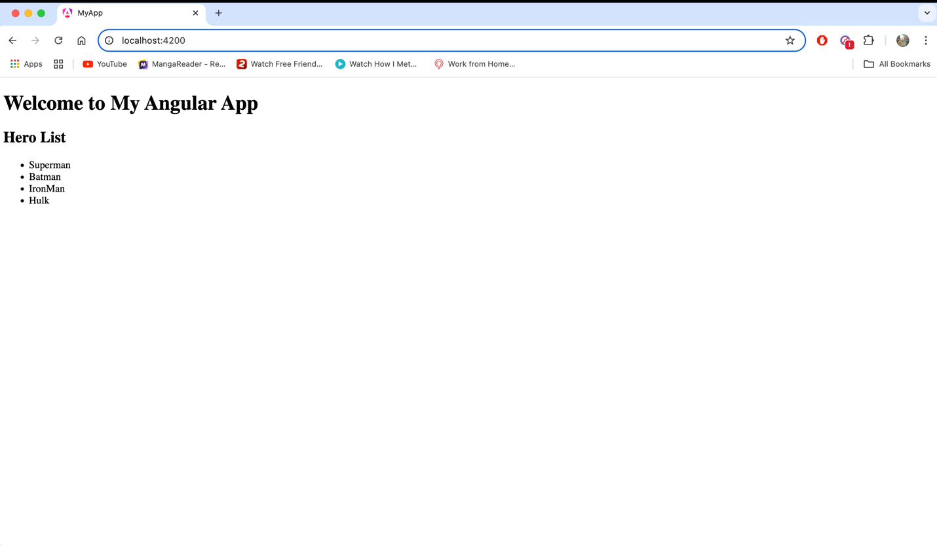

Before and After of Uppercase Input:

Before:

After:

Nested Change realtime change of Hero names happening :

